Supplemental Material

Liquid crystal integrated metalens with tunable chromatic aberration

Zhixiong Shen,a,b Shenghang Zhou,a Xinan Li,a Shijun Ge,a,b Peng Chen,a,b Wei Hu,a,b,* and Yanqing Lua,*

aNational Laboratory of Solid State Microstructures, Key Laboratory of Intelligent Optical Sensing and Manipulation, College of Engineering and Applied Sciences, and Collaborative Innovation Center of Advanced Microstructures, Nanjing University, Nanjing 210093, China

bInstitute for Smart Liquid Crystals, JITRI, Changshu 215500, China

# Section S1: Design principle

According to the Huygens principle, the focusing effect of a planar metalens is the contribution of the refracted light from all points on the lens surface. At any point, the refraction of normal incidence is governed by the generalized Snell’s law50

, (S1)

where *φ* is the phase profile of a lens along the radius *r*, *θ*i and *θ*t are the incident and refraction angle, respectively. *n*i and *n*t are the refractive indices of the media on the incident and transmission side, respectively. *k*0 is the magnitude of the free space wavevector. It is clear that by adding an additional phase factor ∆*φ* independent on *r*, *θ*t remains unchanged. ∆*φ* is designed to increase linearly with frequency *f* to match the resonant phase of silicon pillar meta-units (Fig. S1). As the dispersion ratio d*φ*/d*f* gradually decreases from the center to the edge according to Equation (2) in the main text, silicon pillar meta-units with varying geometries should be adopted along *r*.

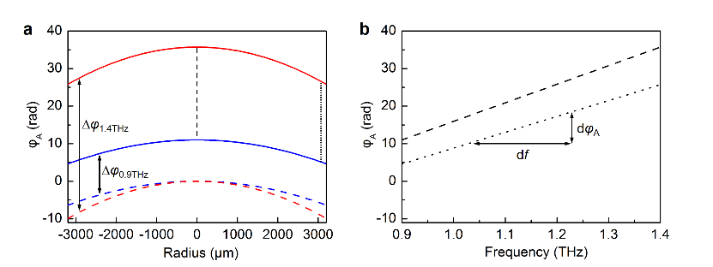

**Fig. S1** Phase and phase dispersion required for a broadband achromatic lens. (a) Phase profiles of a lens with focal length *F* = 15.0 mm at 0.9 THz (blue curves) and 1.4 THz (red curves). The solid and dashed curves represent the phase profiles with and without ∆*φ*, respectively. (b) Dependency of the phase on frequency at two radius positions plotted in (a). The dashed line and the dot line indicate the position *r* = 0 and 3000 μm, respectively.

The waveguide resonance can be excited inside the rectangular-shaped silicon pillar meta-unit,51 which can be directly observed from the simulated magnetic intensity distributions (Fig. S2). The induced THz fields are highly concentrated inside the pillar, contributing to the negligible interaction with their neighbors. As the frequency increases, more power distributions are revealed, indicating higher-order waveguide resonances.

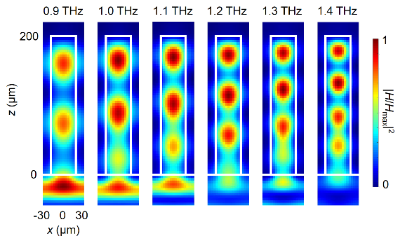

**Fig. S2** Normalized magnetic intensity distribution inside the pillar with *l* = 50 μm and *w* = 36 μm from 0.9 to 1.4 THz.

When no bias is applied, the phase of the achromatic lens (*φ*A) is the contribution of both the resonant phase from meta-unit arrays (*φ*R) and geometric phase from LCs (*φ*G), namely, *φ*A = *φ*R + *φ*G. The mechanism of *φ*R and *φ*G are different, thus these two phases will not disturb with each other. When the bias is saturated, the residual phase is *φ*R. It can be observed from Fig. 1j that at each *r*, |d*φ*/d*r*| decreases compared to the achromatic case, contributing to a decreased *θ*t according to Equation (S1), thus the *F* is enlarged. The vanish of *φ*G induces a larger *F* at 0.9 THz than that at 1.4 THz. Thus, the metalens at bias saturated state is dispersive.

# Section S2: Etching error induced focal length variation

The varying aspect ratio leads to an inevitable increased etching depth from the center to the edge of the metasurface. The cross-section SEM image of the metasurface is shown in Fig. S3(a). The orange-circled (Fig. S3(b)) and blue-circled regions (Fig. S3(c)) are near the center and the edge, respectively. The pillar height *h* along *r* is measured and shown in Fig. S3(d) along with the designed 200 μm. *h* of the pillar gradually deviates from 200 μm when *r* increases. This fabrication error leads to the deviation of *φ*R (Fig. S3(e)). The simulated *φ*R and d*φ*R/d*f* with *h* = 200 μm are both larger than that with *h* = 230 μm. Thus, d*φ*/d*r* becomes larger than the design at the edge of the fabricated lens and *F* is shortened accordingly.

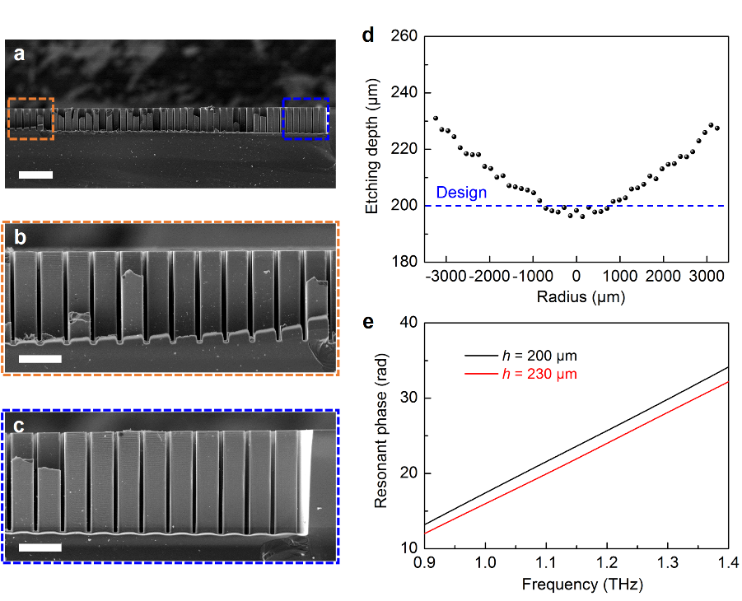

**Fig. S3** (a) Cross-section SEM image of the metasurface. Scale bar: 300 μm. (b) and (c) are the zoom-in images of the orange-circled and blue-circled regions in (a), respectively. Scale bar in (b, c): 100 μm. (d) Measured etching depth along *r* with the designed 200 μm. (e) Dependency of the *φ*R of a silicon pillar meta-unit with *l* = 48 μm and *w* = 10 μm on *f* with two different *h*.

# Section S3: Simulations and measurements of the metalens

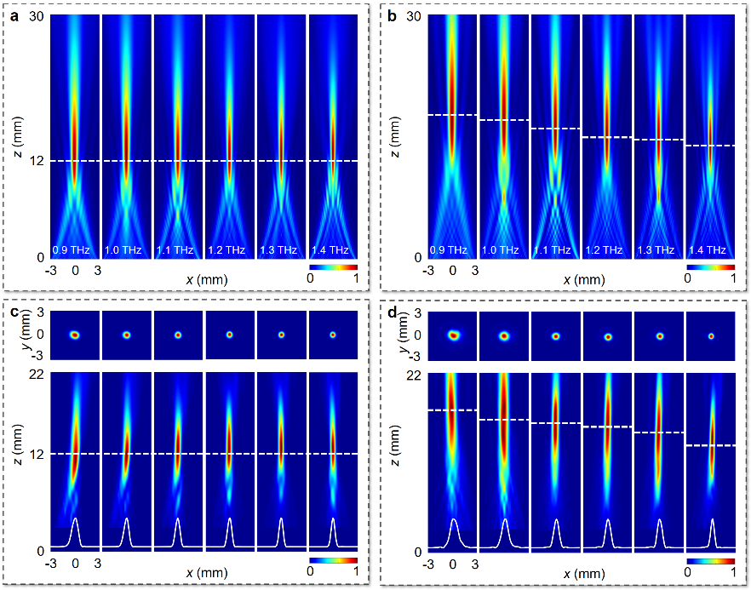

**Fig. S4** Simulated and measured results of the metalens. (a, b) Simulated THz intensity distributions in the *xz*-plane from 0.9 to 1.4 THz at (a) bias OFF and (b) bias saturated state, respectively. (c, d) Measured THz intensity distributions in the *xz*-plane and *xy*-plane (*z* = 12.0 mm in (c) and *z* = 13.0 mm in (d)) from 0.9 to 1.4 THz at (c) 0 Vrms and (d) 75 Vrms, respectively.

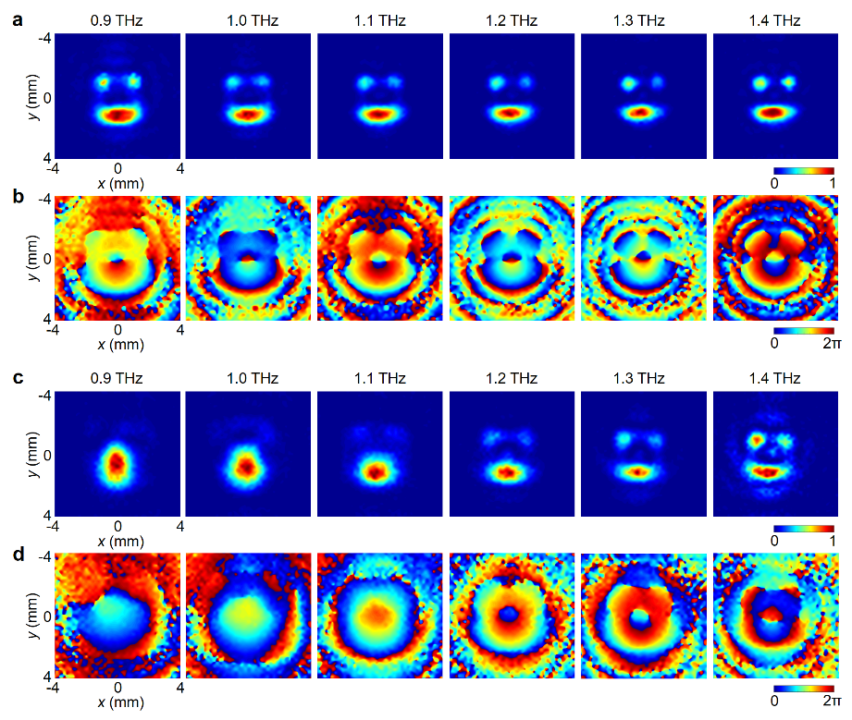

**Fig. S5** Broadband THz imaging using this metalens. (a, b) Measured (a) intensity and (b) phase distributions in the image plane from 0.9 to 1.4 THz at 0 Vrms. (c, d) Measured (c) intensity and (d) phase distributions in the same plane from 0.9 to 1.4 THz at 75 Vrms.

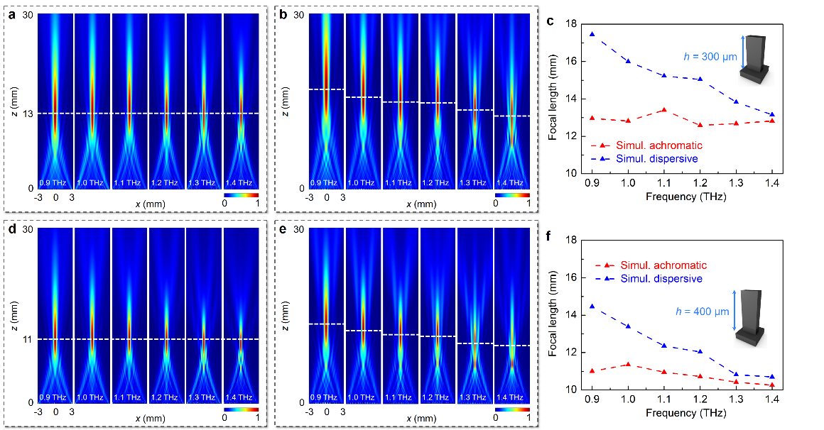

**Fig. S6** Simulations of the metalens with an increased *h* while remaining *l*, *w* and *p* fixed. (a, b) Simulated intensity distributions in the *xz*-plane with *h* = 300 μm from 0.9 to 1.4 THz at (a) bias OFF and (b) bias saturated state, respectively. (c) Dependency of *F* on *f* with *h* = 300 μm. (d, e) Simulated intensity distributions in the *xz*-plane with *h* = 400 μm from 0.9 to 1.4 THz at (d) bias OFF and (e) bias saturated state, respectively. (f) Dependency of *F* on *f* with *h* = 400 μm.

# Section S4: Factors that influence the device efficiency

The device efficiency is mainly influenced by the modulation efficiency of the meta-units and LCs, the THz absorption of the silica substrate and graphene and the imperfect fabrication. The efficiency of meta-units is related to the material and unit geometry, which can be improved via increasing the aspect ratio or introducing asymmetric geometries. The efficiency of LCs (*η*) is the product of two attributions: polarization conversion ratio (PCR) and the THz transmission, which can be expressed by

, (S2)

where Δ*n* is the birefringence of LCs, *d* is the LC layer thickness and *ĸ* = (*ĸ*o + *ĸ*e)/2 is the average absorption coefficient. The former item in Equation (S2) denotes the PCR and the latter describes the absorption loss (or transmission). From Equation (S2), for a target *f* (or *λ*), *η* can be optimized via adjusting *d*. The LC NJU-LDn-4 adopted here possesses a very low *ĸ* and the absorption can be neglected. Thus *η* is mainly related to Δ*n* and *d*. The refractive indices and Δ*n* of NJU-LDn-4 are shown in Fig. S7(a). Here, *d* is chosen to be 250 μm to achieve a balance between PCR and a good photopatterning quality. The measured THz absorption of the silica substrate and graphene is shown in Fig. S7(b). It can be improved via adopting substrates and transparent electrodes with higher transmittance.

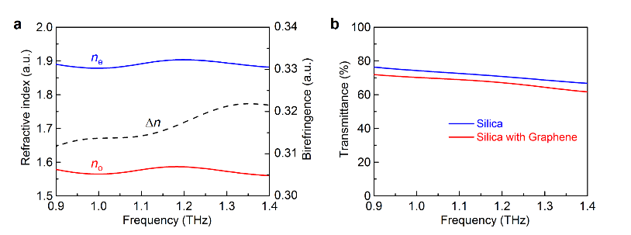

**Fig. S7** (a) Measured *n*o (red curve) and *n*e (blue curve) and ∆*n* (∆*n* = *n*e - *n*o; black dashed curve) of LC NJU-LDn-4 from 0.9 to 1.4 THz. (b) Transmittance of a 500-μm-thick silica substrate with (red curve) and without (blue curve) few-layer graphene from 0.9 to 1.4 THz.

# Section S5: A beam deflector with switchable dispersion

As another example to verify the universality of the proposed strategy, a beam deflector is demonstrated here. The device (Fig. S8a) is composed of silicon pillars with varying dimensions along *x*-axis and LCs with gradient orientations. For an achromatic deflector, the phase distribution *φ*A is written as

, (S3)

where *x* is an arbitrary position along *x*-axis and *θ* is the deflection angle. If ∆*φ* = *kf*+*d* (*k* and *d* are constants), *φ*A can be converted to

. (S4)

The former item in Equation (S4) is accomplised by the *φ*R while the residual *d* is achieved by the *φ*G. The achromatic *θ* is designed to be 17.0° in the spectrum from 0.9 to 1.4 THz. According to the same design illustrated in the main text, silicon pillars with *p* = 60 μm and *h* = 500 μm (aimed to achieve a large dispersion compensation to increase the total unit number of the device) and varying *l* and *w* are selected and arranged in the corresponding *x*-position. The deflector contains 63 meta-units with the dimension of each unit shown in Fig. S8b. According to the *φ*A and *φ*R, the residual *φ*G is obtained and corresponding LC orientation angle (*φ*G/2) is presented in Fig. S8c. As two examples, *φ*A, *φ*R and *φ*G at 0.9 and 1.4 THz are shown in Figs. S8d and S8e. The linearly-inclined *φ*R contributes to a dispersive deflection when *φ*G vanishes. We use the FDTD simulation method to simulate the performance of the designed deflector. At the achromatic state, *θ* at all *f* within the spectrum are around 17.0° (Fig. S8g). When the LCs are set reoriented along *z*-axis, the results distinctly show a dispersive *θ* (Fig. S8h). This property is quantitively analyzed in Fig. S8f. The *θ* gradually varies from 6.0° to 10.3° when *f* changes from 0.9 to 1.4 THz at the dispersive state.

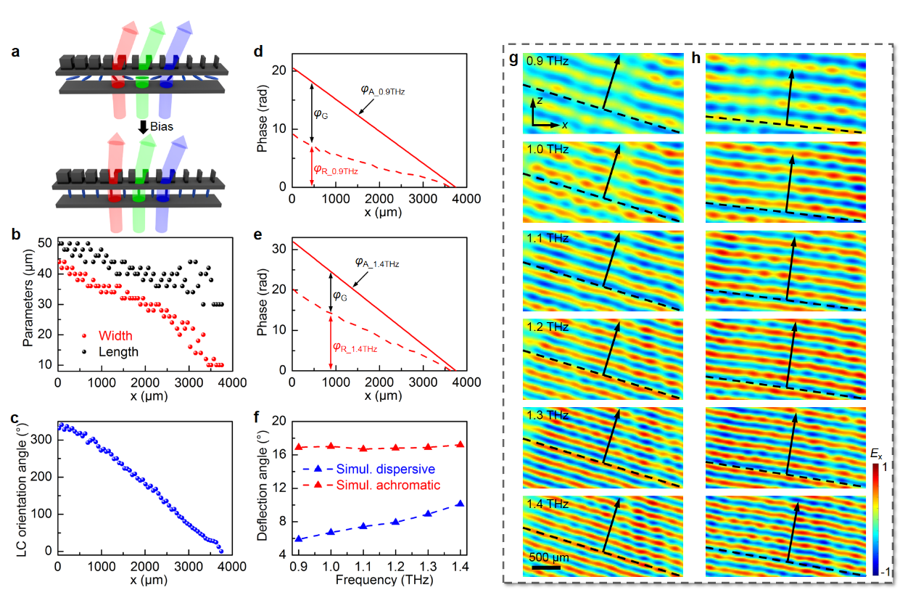

**Fig. S8** (a) Schematic of the function tunability from achromatic to dispersive deflection. (b) Designed *l* and *w* of the silicon pillars along *x*. (c) Designed LC orientation angle along *x*. (d, e) *φ*A (solid curves), *φ*R (dashed curves) at (d) 0.9 and (e) 1.4 THz with residual *φ*G. (f) Simulated *θ* as a function of *f* at the achromatic (red) and dispersive (blue) state, respectively. (g, h) Simulated normalized *E*x-filed in the *xz*-plane at the (g) achromatic and (h) dispersive state, respectively. The dashed lines denote the equiphase surfaces while the solid arrow lines depict the deflection directions.

# Section S6: Fabrication procedure of the metalens

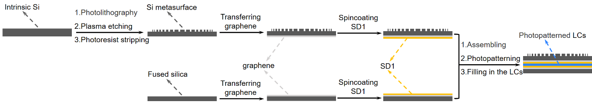

**Fig. S9** Schematic illustration of the fabrication procedure.